SCHOOL ADMISSION DATABASE SYSTEM DESIGN DOCUMENTATION

Introduction

System Overview
The Student Admissions Management System (SAMS) is a relational database designed to digitize and manage the application process for Undergraduate, Diploma, Certificate, and Postgraduate programs. The system streamlines the workflow from the initial applicant submission to final approval by the Registrar (Academic Affairs).

Project Objectives
1. Analyze admission operations.
2. Design a normalized database (up to 3NF).
3. Produce a clear ERD.
4. Implement the database using SQL.
5. Support the admissions management system.

Scope
The database is designed to handle:
- Applicant Profiles: Personal details, contact information, and demographics.
- Institutional hierarchy: Schools, department and the programs.
- Applications: The transactional table linking a student to a program for a specific intake.

Functional Requirements
• Register and admit students.
• Store student’s personal information.
• Manage programs allocation.
• Track applications.

Non-Functional Requirements
• Reliability
• Scalability
• Security
• Usability
• Maintainability
Entity-Relationship Design

Core Entities
The database is built around three primary functional areas:
- Institutional Hierarchy:
  - Schools: The highest academic unit (e.g., School of Computing).
  - Departments: Functional units within schools (e.g., Computer Science Dept).
  - Programs: The specific courses offered (e.g., BSc. Computer Science).
- Applicant Data:
  - Students: The central entity containing unique applicant details.
  - Student qualifications: highlights the student qualifications.
  - Documents. Stores the uploaded documents by the student.
- Application Management:
  - Applications: The transactional table linking a student to a program for a specific intake.
  - Intake: Defines the admission period (e.g., January 2026).
Data Dictionary (Schema Description)
Below is a description of the critical tables and their roles in the system.
Students
Stores the permanent profile of an applicant.
- Primary Key: student_id (INT)
- Key Attributes:
  - first_name, last_name: Personal identification.
  - id_number: Unique National ID or Passport number.
  - email, phone: Contact details.
  - Demographics: Gender details.
  - Guardian details

Application
The central hub for the admissions workflow.
- Primary Key: application_id (INT)
- Foreign Keys: student_id, program_id, intake_id, branch_id.
Student-program
Details the flow of the application.
- Primary key: sp_id
- Foreign keys: student_id, intake_id, application_id and program_id
- Workflow Attributes:
  - date_received: The date the form was submitted.
  - dept_status: Enum ('Pending', 'Approved', 'Rejected').
School
Details on the school to which departments belong in
- primary key: school_id
- school name

Department
Highlights departments in which programs belong to
- primary key: dept_id
- foreign key: school_id
- dept_name
Programs
These are the programs a student applies to pursue
- primary key: program_id
- foreign keys: dept_id, program_level_id
- program name
Short course
These are separate courses taking as shorter spun that can be pursue as solo courses or as one pursues another program of a different level
- primary key: sht_id
- foreign key: school_id
- sht_name
Student qualifications
Majors on the student’s qualifications and previous qualifications
- primary key: qid
- foreign key: student_id
- q_type
- grade

Module
Highlights the mode of sponsorship
- primary key: mid
- foreign key: students_id
- module_name
Branches
The institutions branches. Based on an assumption that not all programs are available in all branches
- primary key: branch_id
- branch name
- accepting undergraduate, postgraduate(boolean)

Handling Redundancy (3NF Compliance)
To ensure the database is in Third Normal Form (3NF):
- Branches & Intakes: Instead of typing "Main Campus" or "Jan 2026" repeatedly in the Application table, these are stored in separate lookup tables (branches, intake). The applications table only stores the ID (e.g., branch_id).

Entity Relationship Diagram (ERD)
The ERD illustrates:
- One-to-many relationships between branches and programs
- Student enrollment linked to programs and intakes
- Reference tables for study modes and sponsorship types

Entity Relationship Diagram (ERD)

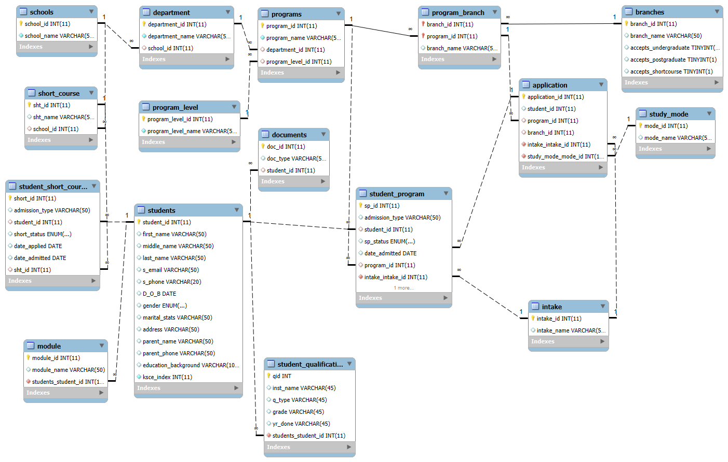

5. Conclusion
This database schema accurately reflects the requirements of a University’s application forms. It transforms the static paper-based process into a dynamic relational model that ensures data integrity, minimizes redundancy, and provides a clear audit trail for admissions approvals.

